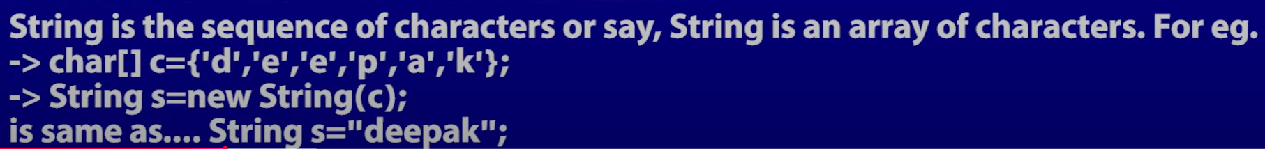





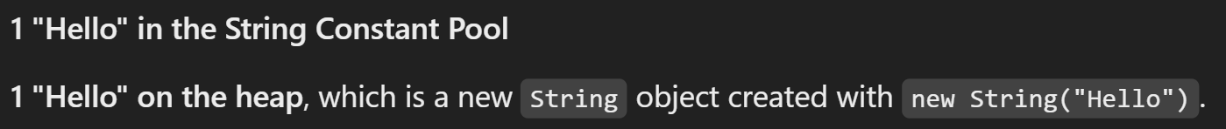

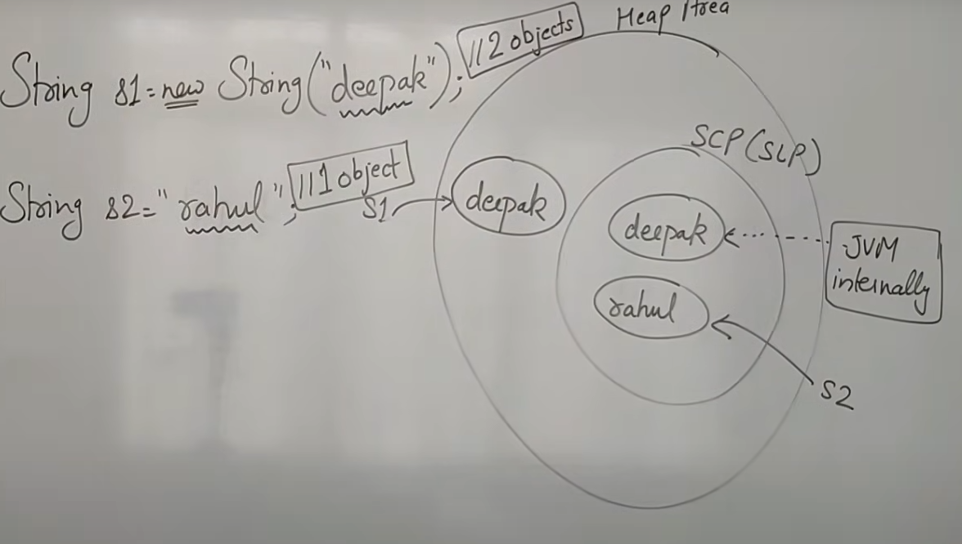



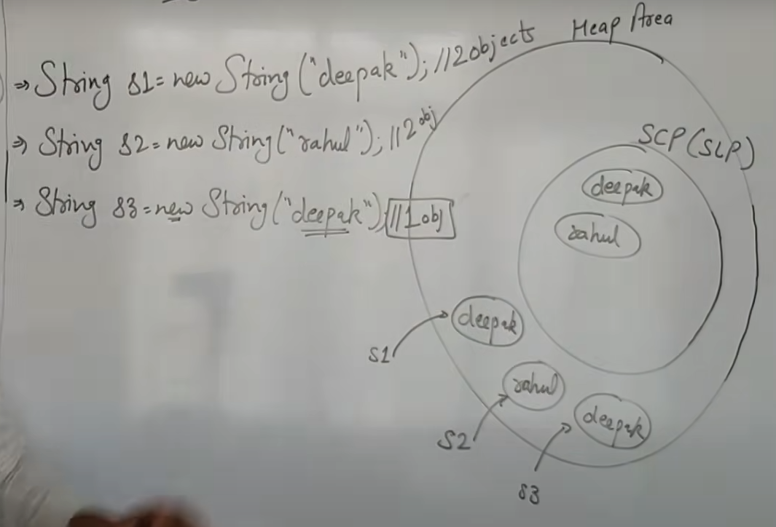







String s = “Raj”;

When you use s.concat("dip"), a **new string object** "Rajdip" is created on the **heap**, not in the **String Constant Pool**.

The String Constant Pool only contains string literals (e.g., "Raj"), not the result of string concatenations done at runtime.

If you want the concatenated string "Rajdip" to be placed in the String Pool, you need to call .intern() on the resulting string:

java

Copy

String result = s.concat("dip").intern();